**Bilkent University**

Department of Computer Engineering

**CS 319 Project**

*Best Trade*

Final Report

Group Members

* Ezgi Çakır
* İbrahim Berker Kırdök
* İlhami Özer
* Irmak Tural
* Berk Türk

Table of Contents

1. Implementation 3

2. The Changes Made in Implementation Stage and Non-Implemented Parts 4

3. User’s Manual 6

3.1 Introduction 6

3.2 Installation 6

3.3 Using the BestTrade 7

# **Implementation**

We started the implementation by considering our design and layers. It is organized into three subsystems. First we started to implement the classes of User Interface Subsystem. In this subsystem we implemented classes of screen which extend JPanel and UIManager that extends JFrame and create a frame. In this class only first panel added to frame. The other panels are added and set visibilities as true based on the operations that user would do. Each panel creates the panels that comes after itself.

In the other layer Trade Subsystem we implemented the ModelClasses. In model classes the objects are implemented. Our model classes have inheritance, parent child relationship. The client objects must kept their username, password, name, surname, email, university, user id , messages, items that is sent and received and items that they own. So the Client Class is created with these attributes and set and get methods are written to provide data encapsulation. The User, NewClient and Admin classes extend the Client Class. New User object has an additional attribute, ActivationCode. In these classes, throughout super(), the constructor of Client Class is invoked. This hierarchy and this is forced in Furniture, Book, Notes classes. Their parent is Item class and its attributes are String title, String category, String description, double price, String condition, ImageIcon photo, int itemId.

Then we started to implement the class of Database Management subsystem. We install the WampServer and create the database, tables and arrange it according the our objects and their attributes in MySQL. Throughout the class of Database, using SELECT * FROM, INSERT * FROM, it is specified that which information is pushed or taken from where. In the other classes, Database objects are created and the functions are applied to that object. The graphical user interface is not challenging, but arranging panels and transition between them by buttons and arranging their visibilities take time. Also sending mail is challenging. A class which imports a library javax.mail is required. So we added a SendMail. It is needed to create a session, declaring the message, subject, sender and receiver. The classes of Trade Subsystem is not challenging, because the our design of hierarchy is not complicated. The implementation of Database Management Subsystem is challenging for us. Because MySQL and the database is a new notion for us. We had some problem when a photo of an item is uploaded and retrived however we solved this problem. Therefore, currently, when the user pushes data to database, the data is refreshed. We did not make major changes on our design while implementation.

# **2. The Changes Made in Implementation Stage and Non-Implemented Parts**

There is not any change in significant features and properties of the project. But while implementation, we add or change some objects, attributes, classes, panels to create the project in more efficient way.

Additional Attribute: It is added a new attribute “title” to our Item

class. So our objects Furniture, Book, Notes have a title.

Change in Types of Attributes: The Client and the classes that extend to it take Item objects in an ArrayList <Item>. Also the Messages objects are taken as ArrayList as parameter.

Additional Classes: We added a new class called SendMail that provide Client to send a message with a subject. The connection is provided in that class, throughout importing javax.mail.

Additional Screen Implementations: We added new screens that does not exist in our Analysis Stage. We added ActivationCodeScreen that take input from user the activation code to sign up, EditItemPanel to modify the features of the item that is added before, MyProductsPanel that displays use the item that is added by that user, MessageScreen that displays messages of the user. ChatPanel is added to display a chat between two users.

Change in GUI implementation: In our Design Stage, we design our UIManager classes with its display methods. But we implemented in different way. We have just one frame. The other panels added on that frame in different classes.

Removals: The deleteItem() method does not exist in Admin class.

# **3. User’s Manual**

## **3.1 Introduction**

BestTrade is a Java application using database. User should have an account with unique username and password to login the system. BestTrade allow clients to add products (books, furnitures, notes) to sell and view products to buy. User can search the product that they want, while doing that they can use filters and display the products that fits their demand most.They can reach detailed information of the products and message to owner of the product throughout the system. Also they can edit the information of products and themselves.

## **3.2 Installation**

**System Requirements:**

It requires Java Runtime Environment and WampServer for database.

## **3.3 Using the BestTrade**

When user started the BestTrade, the Login Screen (Figure 1) is displayed. To login the system, user should have an account with a unique username and a password. If the username and password is not matched, error message is displayed. The user who does not have an account can click on the “Sign Up” button to create an account to log in the system. In Sign Up Screen (Figure 2) user enters the information which are Name, Surname, User Name, University Name, E-Mail Address and password. When user clicks on “Sign Up”, an activation code is sent and the Activation Code Screen (Figure 3) is displayed. User should enter the activation code. The activation code must be accurate to register.

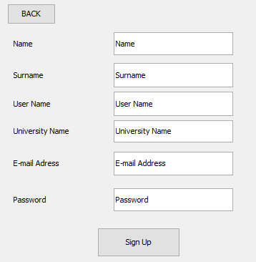

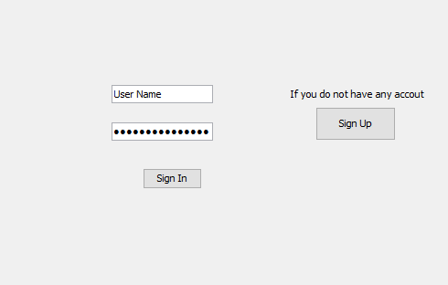

Figure 1: Login Screen Figure 2: Sign Up Button

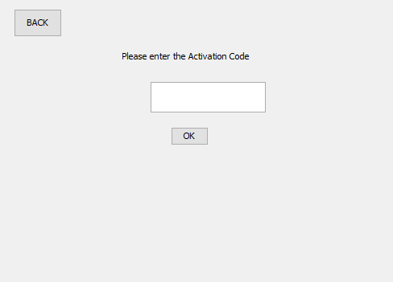

Figure 3: Activation Code Screen

In the Login Screen if the username and password is accurate and matched the user signs in. When user signs in Trade Screen (Figure 4) is displayed. User has 3 option in that screen: Adding product to sell, searching a product to buy or view own profile. The user is led to make that operations by the buttons “Add Product To Sell”, “Search For Product”, “View My Profile.”

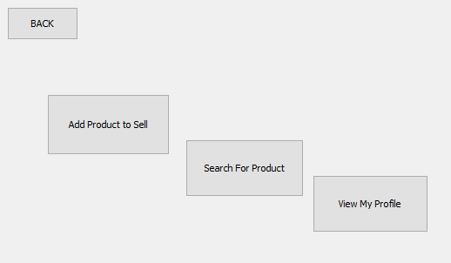

Figure 4: Trade Screen

When user clicks on “Add Product To Sell”, Add Item Screen (Figure 5) is displayed. User can input information of item. The information of items are; category (Book,Furniture, Notes),price, condition, title, description of item. Also user can upload photo of item by pushing the “OK” button, near “Upload Photo” label. When the “SAVE” button is clicked, the item is added to the system and ready to be sold.

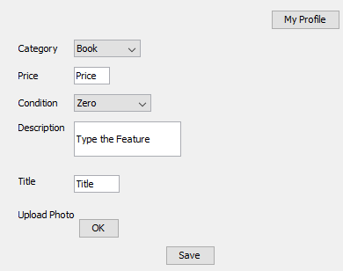

Figure 5: Add Item Screen

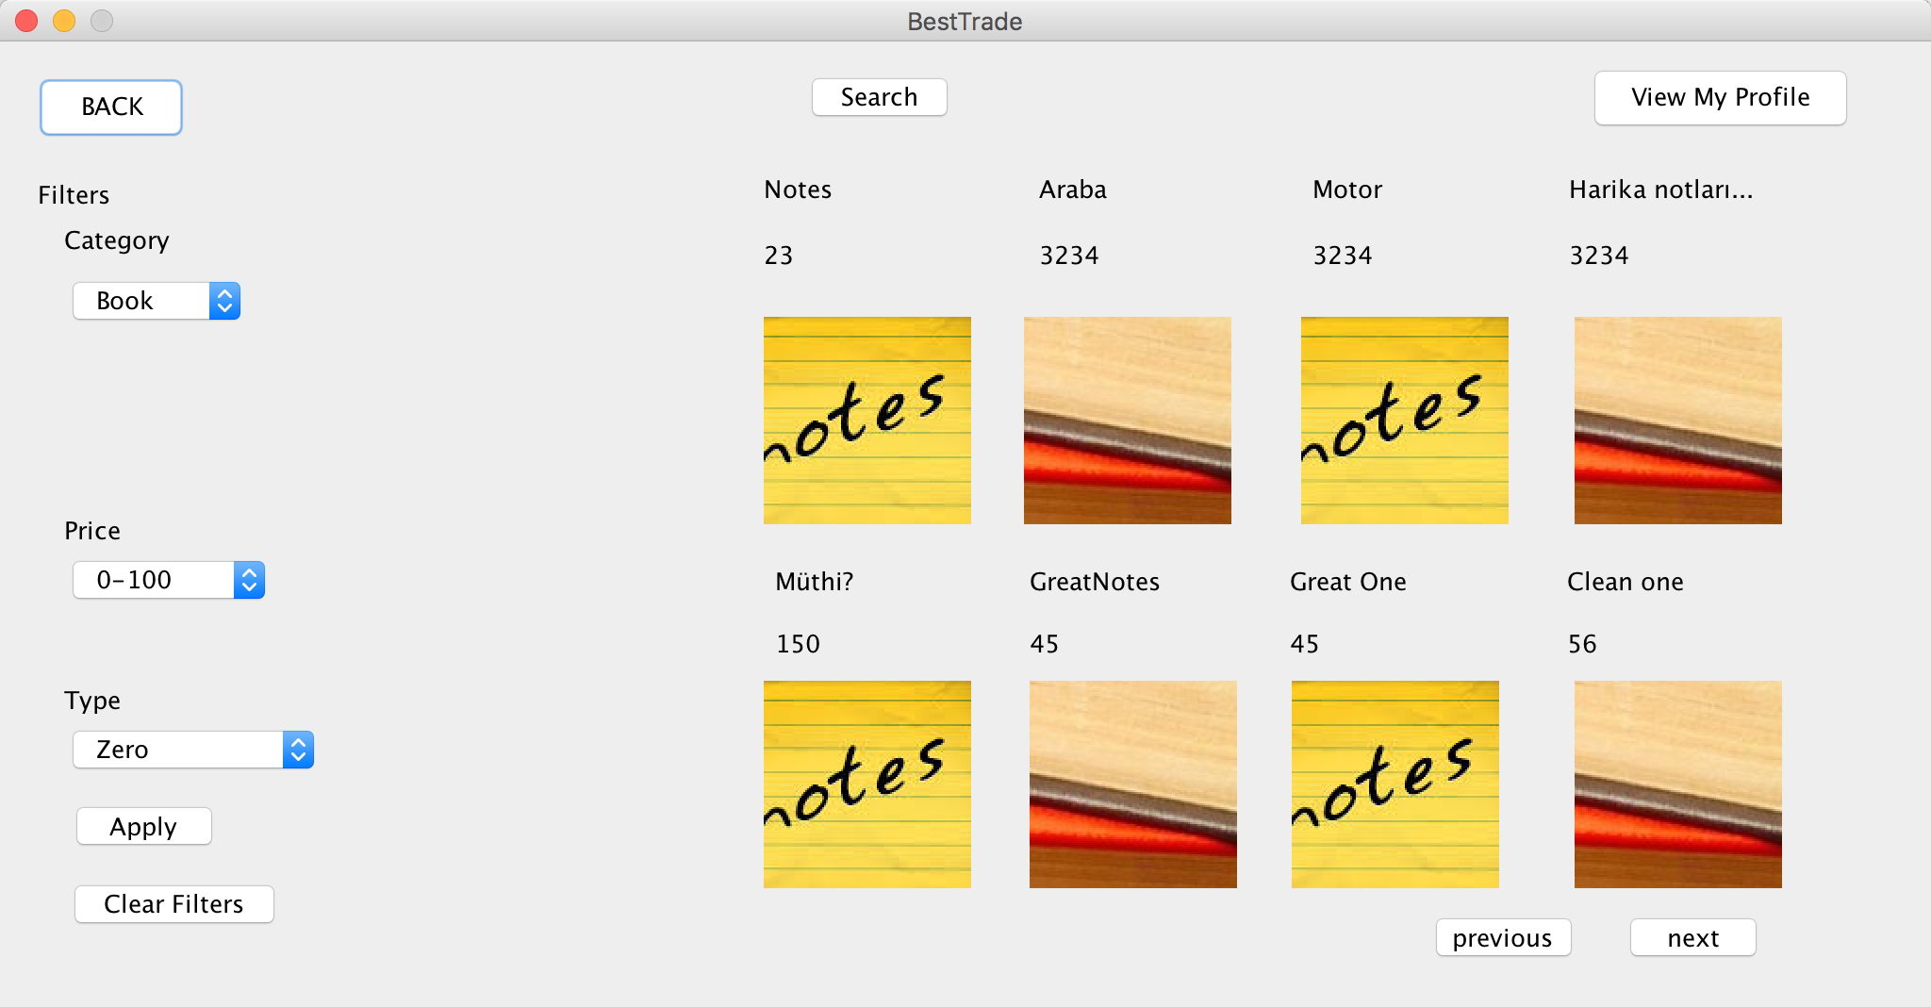

Figure 6: Search Item Screen

When user click on “Search For Product” button in Trade Screen, Search Item Screen (above-Figure 6) is displayed. The user enters the product’s name in that he wants to search and also can filter the products that will be displayed by arranging the filters. Based on the information and filters the items are displayed with their name and photo. When it is clicked on the item, View Item Screen(Figure 7) is displayed. User can see the detailed information of Item from that screen. Also user can send message to owner of the item by clicking on button “Send Message”. Through Send Message(Figure 8) screen that is displayed after the click, he enters the username of the user that he wants to send the message, the subject, texts the message and send by clicking “Send” button.

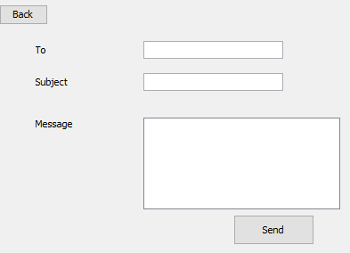

Figure 8: Send Message

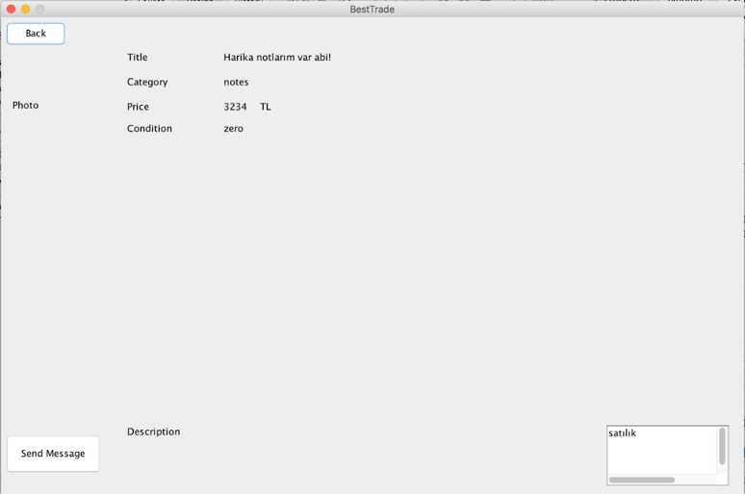

Figure 7: View Item Screen

When user clicks on ”View My Profile” button , he can see his information in My Profile Screen (Figure 9). By clicking on “Messages”, the user can see the messages that is taken from Message Screen. Also from My Profile Screen user can open the screen by clicking “Sold Products” button to see his products in My Products Screen (Figure 10) User can also modify his information by clicking “Edit Profile” on My Profile Screen. After the click, the Edit Profile Screen (Figure 11) is displayed and throughout that screen user can enter and change the information which is entered when he signed up. Also he can change his password from that screen. User completed the change by saving modifications by clicking “ Save Changes” button.

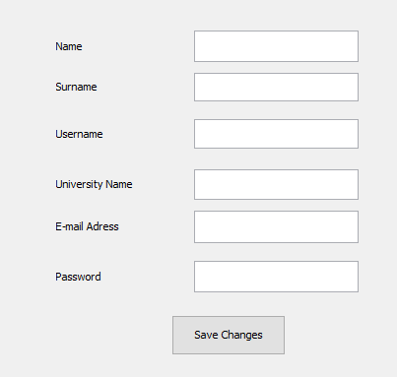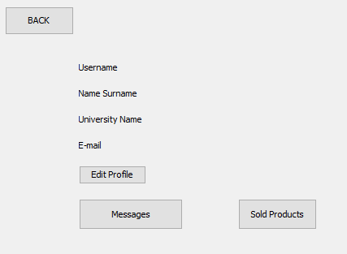

Figure 9: My Profile Screen Figure 11: Edit Profil Screen

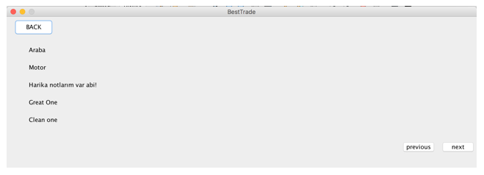

Figure 10: My Products Screen

Also user modify the information of the products by clicking on the labels on My Products Screen. After the click Edit Item Screen(Figurre 11) is displayed

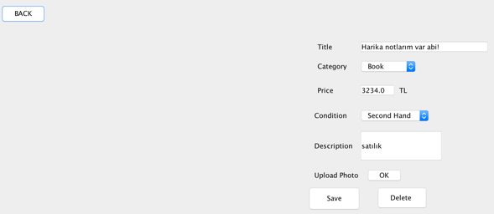 Figure 11: Edit Item Screen